P2 Notes
- Installed opencv
- https://www.geeksforgeeks.org/how-to-install-opencv-for-python-in-linux/

pip install images2gif
pip install pillow
pip install vidmaker
pip install pygame
pip install imutils

pip install vid
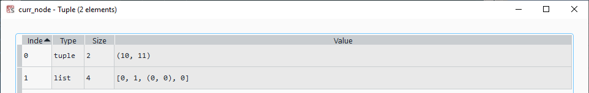
P
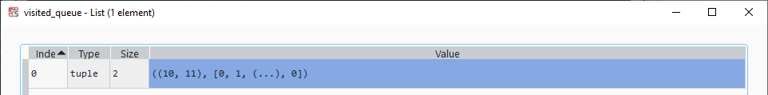

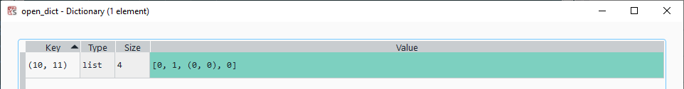

debug_counter = debug_counter + 1

curr_node = nodeWithLowestC2C(open_dict)

# curr_node = min(open_dict.items(), key=lambda x: x[0])
curr_node_x = curr_node[0]
curr_node_y = curr_node[1]
curr_coord = (curr_node_x,curr_node_y)
node_val = open_dict.pop(curr_coord)
curr_node_coord = (curr_node_x, curr_node_y)
curr_node = (curr_node,node_val)
visited_queue.append((curr_node,node_val))
# visited_queue.append((child_coord,[99999, node_idx, curr_node_coord, curr_parent_idx]))

